Laika's passion for camper vans.
Here is the new Ecovip 645 Camper Van

San Casciano in Val di Pesa, July 2022 - Live unique life experiences with and in the motorhome. This is one of Laika's targets, which is reflected in the new Ecovip 645 Camper Van, thanks also to the multifunctional space at the back that can be adapted to different types of use.
Your new travelling companion by Laika is available on a 140 hp Fiat Ducato 35 Light chassis and has an exterior length of 636 cm.

DOLCE VITA - ANYTIME, ANYWHERE

At the heart of the layout of the new Ecovip 645 Camper Van is the rear area, featuring a multi-purpose, dynamic environment to accommodate the crew and any friends in complete comfort. The spacious U-shaped dinette (192x175x195 cm) has four windows (two side, two rear), a panoramic maxi roof portlight and can be used both as a convivial day room and as a comfortable and practical bedroom. In the daytime version, while parked, it can comfortably accommodate up to six people around the revolving table supported by a nautical-inspired leg.
The rear environment can then be used:
- as a U-shaped lounge
- as a "face-to-face" dinette. When the table is not in use, it is stored together with the leg in the storage compartment at the base of the rear left chest of drawers, so that the slatted bed bases can be extended and the two longitudinal sofas can be transformed into twin beds in the same way.
- with twin beds
- with maxi double bed. In this case, it will be possible to sleep both longitudinally and transversely thanks to the approx. 2x2 metre useful surface area created by using the extendable bed bases.
A unique and exclusive multifunction feature offered by Laika.

DESIGN, LIGHTING AND INSULATION:
NEW GENERATION ECOVIP CAMPER VAN

The Ecovip Camper Van 645 is available in four exterior colours: white as standard and optionally in Lanzarote Grey, Expedition Grey or Black Metallic. The driver's cabin with cut-out roof integrates the living area of the compartment in the best possible way.

The vehicle's brightness is ensured by the maxi skylight and windows, as well as by dimmable LED lights that achieve the optimum degree of brightness at any time of day, while the dedicated TV area with peninsula makes use of the backlighting system, which is useful to avoid straining the eyesight.

The diesel heater is standard and, to prevent heat loss, the Ecovip Camper Van 645, like the 600 and 540, has full insulation with Ecofiber 40: an insulation material made of polyester fibres and an aluminium protective layer.
To ensure maximum protection from cold, but also from heat, the vehicle is fully insulated, even in the areas most exposed to the air such as the rear doors and side door. Roof and floor are insulated with XPS: extruded polystyrene foam.

ALL THE COMFORT YOU NEED

Also in the Ecovip Camper Van 645 the design, materials and finish draw inspiration from the Ecovip range: furniture available in "Rovere Moka" (standard) or "Pero Toscano", elegant wall units, table and kitchen tops surrounded with elegant copper edging, and drawers with convenient retractable handles. In addition, there is an adjustable sofa, a fold-down wall-mounted table and two portions of double floor, in the front and rear living areas, to provide additional insulation and storage space.

The Ecovip 645 is a versatile vehicle as you would expect from a camper van, but at the same time has all the comforts you need to enjoy your holiday comfortably. Starting with the kitchen equipped with an additional worktop with fold-down shelf, maxi-drawer and two lower drawers for storing everything you need just like in your home kitchen. The 90-litre refrigerator is standard while an optional 138-litre maxi-refrigerator is also available.

In the bathroom, even in the Ecovip 645, the window is standard. It is very useful not only for providing more airiness and brightness, but also because it allows the shower jet to be used from outside, with both hot and cold water. As with the Ecovip Camper Van 600, the toilet is variable in volume thanks to the standard VarioBad: the washbasin wall rotates, creating a separate shower.

ECOVIP 645 CAMPERVAN

- Fiat Ducato 35 Light 140 HP
- Length / Width / External height: 636/205/270 cm
- Sleeps: 2
- Right / left rear bed (W x D): 192 x 60 / 175 x 60 cm
- Rear double bed: 196 x 192 / 175 cm
- Heating with hot air system 6 kW Diesel

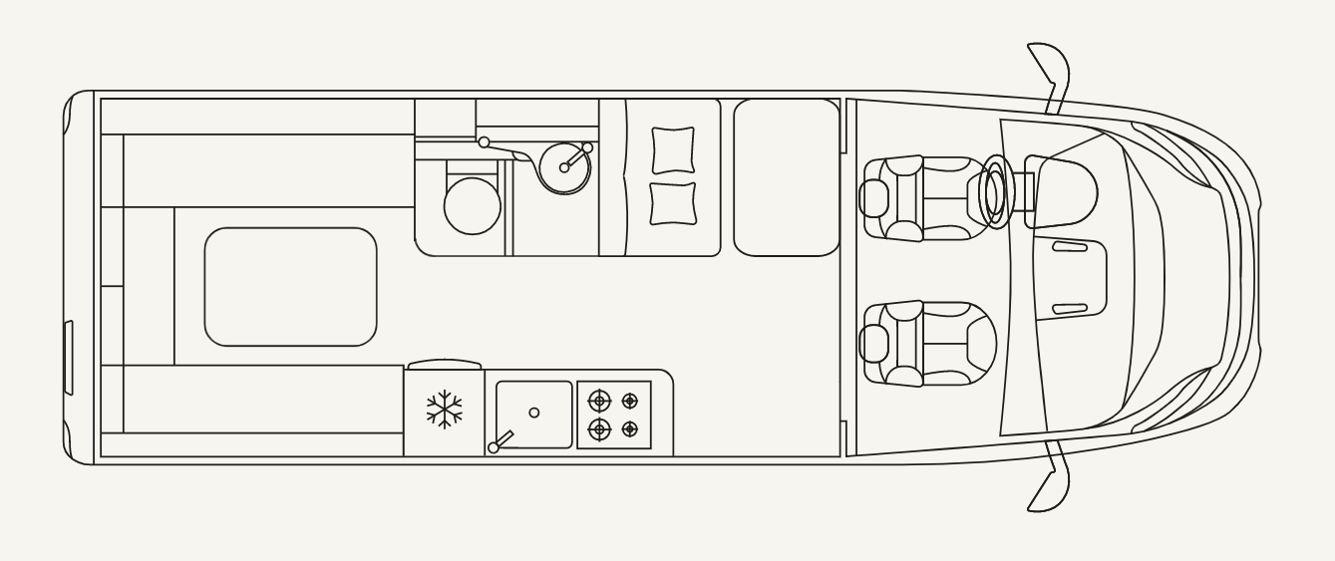

LAIKA, WITH YOU ON YOUR TRAVELS SINCE 1964

58 years have passed since, in 1964, Giovanbattista Moscardini founded LAIKA, calling it after the first dog launched into space. Fascinated by the space adventures and the new horizons that were opening up, Moscardini laid the foundations for what is now an avant-garde company, which stands out for its production of design and excellent construction technique. Laika Caravans belongs to the Erwin Hymer Group and manufactures vehicles designed with excellent construction techniques, made to last and suitable for any climatic situation. Customer satisfaction is Laika’s main goal. Thanks to its team with extensive competence and experience, it creates vehicles with attention paid to the smallest details. www.laika.it/en

ERWIN HYMER GROUP

The Erwin Hymer Group is a wholly-owned subsidiary of THOR Industries, one of the world's leading recreational vehicle manufacturers with over 31,000 employees. The Erwin Hymer Group brings together motorhome and caravan manufacturers, spare parts specialists as well as rental and financing services under one roof. The Erwin Hymer Group includes the motorhome and caravan brands Buccaneer, Bürstner, Carado, Crosscamp, Compass, Dethleffs, Elddis, Eriba, Etrusco, Hymer, Laika, LMC, Niesmann+Bischoff, Sunlight and Xplore, the motorhome rental companies Crossrent, McRent and rent easy, the chassis specialist Goldschmitt, the spare parts specialist Movera and the freeontour travel portal. For more information, see the web site www.erwinhymergroup.com

Contacts:

Anna Maria Fusi: e-mail - annamaria.fusi@laika.it- Tel. +39 055 80581

