LAIKA PRESENTS THE NEW KREOS
TRUE ICON OF TRAVEL

San Casciano in Val di Pesa, August 2021 - The Kreos is one of the most iconic and beloved Laika models: a synonym for elegance, power and high technology. For the 2021-2022 season, Laika presents a completely revamped Kreos low-profile, from exterior to interior, from technique to style, for a perfect combination of personality, driving comfort and refined Italian design. The new range is represented by the Kreos L 5009, a low-profile model with an overall length of 799 cm and equipped with rear twin beds and an L-shaped dinette.

Automotive design and stability

Driving the new low-profile Kreos is an unforgettable experience: the Fiat AL-KO Heavy chassis provides driving comfort, solidity and safety. The elegant opening fibreglass dome with maxi Skyview (116 x 73.5 cm) allows optimum enjoyment of natural light while ensuring a change of air and is fully insulated. To ensure strength and stability even in the most demanding weather conditions, in addition to the dome, the one-piece rear wall and roof are also made of fibreglass. The assembly of the body with direct wall-to-roof and wall-to-floor connection gives Kreos a linear and harmonious look, but above all excellent insulation and very high mechanical resistance. Speaking of look, ultra-flat automotive windows with aluminium frames are not only durable and of high quality, but also nice to see.

Maximum insulation and heating to enjoy the Dolce Vita in every season

Travel freedom means being able to travel in all seasons and temperatures. The low-profile Kreos allows you to set off when you feel like it, without having to check the weather forecasts or temperatures: you decide when it's time to go! Good insulation can really make a difference: the new Kreos was designed to accompany the most demanding travellers wherever they want to go and whatever the weather. The self-supporting body is made of three layers (aluminium/XPS/aluminium) with increased thickness (40 mm). Roof and under flooralso consist of three layers: fibreglass/XPS/aluminium. This guarantees maximum insulation and the freedom to enjoy life in your motorhome without worrying too much about the weather or the climate outside.
The new, thicker side doors have thermal break frames to prevent heat loss. The double through-floor with a useful height of 25 cm serves both as insulation - acting as a thermal chamber - and as stowage space: it is easily accessed through the convenient hatches in the main floor and through two side hatches on the right and left of the living area, so that everything is within easy reach.
The water heating is distributed evenly in all areas of the vehicle. The freedom to experience motorhomes in comfortable, light clothes in any season without feeling cold is priceless! In addition, the thermostatic control is independent for the rear room, so you can sleep at the ideal temperature without wasting energy.

State-of-the-art technology and multifunctional systems

Everything is under control on board, thanks to the latest-generation electrical system with CI-Bus technology: networking and control, for example, of lighting, air conditioning, battery charging, etc. The wiring is located in the double floor, allowing easy installation and repair. The battery compartment is inside the double floor and easily accessible (also lithium battery system-ready). The electrical system components are grouped together in the dedicated and protected technical compartment in the rear garage: everything is tidy and easy to manage.

Convenient luxury: many solutions to pamper yourself while travelling
Even the smallest comforts contribute to making a motorhome the best travelling companion. Little daily luxuries that make us feel like kings and queens of our four-wheeled home. On the new low-profile Kreos, the XL Premium plus living unit door (192 x 60 cm) with window is equipped with a 3-point safety lock, insect screen and central locking with remote control. The electrically operated external maxi step (70 cm) allows you to get on the vehicle comfortably. For the more sporty and those who don't want to give up their passions on holiday, it has never been easier to take their bicycles, beach umbrellas and sports equipment with them, thanks to the maxi garage (218 x 129 x 124.8 cm) with symmetrical side doors (120 x 100 cm) opening upwards, with a thermal break frame, integrated hinges and security locks. In addition, the garage is illuminated and heated, with non-slip floor, equipped with light switches on both sides, sockets and with 250 kg payload. There is plenty of room for everything! Wine lovers will appreciate the private wine cellar in the garage (optional), a compartment in which to store the finest bottles. A true luxury, only for connoisseurs!
Classy interior for suite-like comfort

The interior has been designed in every detail to create a spacious, airy and bright environment. In addition to the panoramic opening Skyview, the new Kreos is equipped with an electric opening sunroof (96 x 65.5 cm), which can also be used while driving (optional as an alternative to the drop-down bed). Plenty of natural light and fresh air to make the most of every space. Sophisticated design and furniture lovers will not be disappointed: the furniture has a unique touch of class, with real wood doors for a sophisticated yet natural feel inside the room. The living room is a room to share: it can accommodate up to 7 people during stopovers, also thanks to the new system of converting the seats in the direction of travel, to create an additional seat in the dinette. Eating with friends around the elegant round table will have a special flavour. The entire space is designed for relaxation, perhaps in front of the 32″ TV (optional) with electrically operated movement system visible from both the drop-down bed and the living room: maximum comfort, just like in a real suite!

A Master Chef's kitchen

Whether you are an experienced cook or a beginner, a gourmand or a perpetual dieter, the Kreos L 5009 kitchen is perfect for giving you your favourite dishes. A space entirely redesigned to combine elegance and practicality. The worktop, which is also available in high-quality Corian (optional), is equipped with a double sink. The gas oven is standard, as is the portlight and the 153 l maxi refrigerator with AES system and convenient door that can be opened from the living area and the rear. In the kitchen of the new Kreos, nothing is left to chance: the matt black tap with flexible arm (optional) makes it easy to wash vegetables, fruit, plates and everything else you need, just like at home! A true Master Chef's corner with a choice of 2 types of kitchens: Standard, or Standard with optional dishwasher. And last, for those who don't want to miss out on a good cup of coffee or espresso, even (and especially) on holiday, an optional coffee machine holder in Corian is available, to start every day on the right foot, enjoying your favourite coffee.

The well-being of a spa

Letting yourself be enveloped in the shower of the new Kreos is a true moment of well-being, a small daily luxury that cannot be renounced! The large designer shower enclosure has a wood-look floor, double shower head, wellness shower column (optional), lighting and shelves. Thanks to the smart design of the space, the bathroom can be converted into a single large room that is separate from the rest of the vehicle, allowing you to enjoy a moment of privacy in comfort. Every detail is elegantly finished, such as the large mirrored surfaces and the matt black tap (available as an optional extra): a true spa for moments of well-being!

Regenerate every night in a versatile area

After a day spent discovering new destinations, or perhaps enjoying your favourite beach, there is nothing better than finding your bed, deep into the arms of Morpheus. The sleep area of the new Kreos L 5009 is equipped with all the comforts to make even your resting moments unforgettable. The two large rear twin beds (200 x 80 cm) have an adjustable headboard and perimeter heating: even when it's cold outside, this room is as warm and cosy as a nest. For those who prefer to sleep with their partner in arms, the two beds can be converted into a large double bed (199.6 x 206 cm). In addition, the beds are equipped with a high-comfort spring suspension system, because getting a good night's sleep when travelling can make all the difference!
When travelling, it's nice to be able to take your favourite clothes with you, whether they are sporty or for everyday use, but also something for a special occasion, why not? The double wardrobe allows you to hang your clothes or store your shoes neatly and conveniently. An additional, optionally available wardrobe with pull-out compartments is useful for storing even more clothes, all with automatic interior lighting.
Additional guests? No problem at all: the optional front drop-down bed (140 cm wide), electrically operated and integrated into the ceiling, can comfortably accommodate your travel companions for as many nights as you like.

Laika dedicates the new Kreos to those who love to travel in freedom, to those who love elegance and design, to those who have a technological soul but cannot give up the magic of a warm and welcoming environment. A travel icon restyled in its core and aesthetics, to satisfy not only experienced motorhome owner but also new travellers, accompanying them to their next destination.

KREOS L 5009
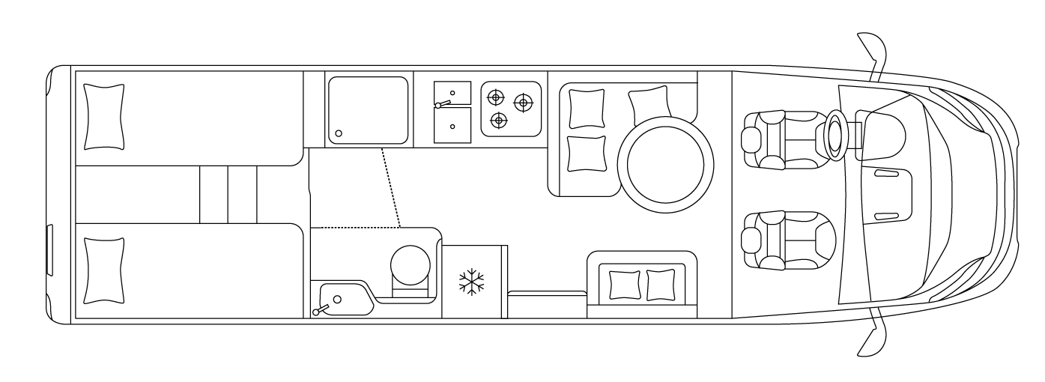

- Fiat Ducato Heavy, 140 HP, Turbo Diesel Common Rail
- AL-KO AMC chassis with reinforced suspension
- Length / Width / External height: 799 / 230 / 299 cm
- Approved capacity: 4 (S)
- Sleeps: 2 (S) + 2 (O)
- Ground clearance: 250 mm
- Garage dimensions (D x H x W): 218x129x124.8 cm
- Left / right rear bed: 200x80 / 200x80 cm
- Electric drop-down bed (optional): 190x140 cm
- Refrigerator, 153 l
- Heating with hot water system 6 kW

TRAVELLING WITH YOU SINCE 1964
57 years have passed since, in 1964, Giovanbattista Moscardini founded LAIKA, naming it after the first dog in space. Fascinated by the adventure of space and the new horizons that were opening, Moscardini lay the foundations for the cutting-edge company of today, which is distinguished by its designer production and excellent construction technique. Part of the Erwin Hymer Group, Laika Caravans creates vehicles designed with state-of-the-art construction techniques, made to last and designed for all climates. Customer satisfaction is the key objective of Laika, which thanks to its team – with a long history of competence and experience – creates vehicles where attention is paid to the smallest detail. www.laika.it

ERWIN HYMER GROUP
The Erwin Hymer Group is a 100 percent subsidiary of Thor Industries, the world's leading manufacturer of recreational vehicles with more than 25,000 employees worldwide. The Erwin Hymer Group unites motorhome and caravan manufacturers as well as motorhome and caravan accessory specialists, hire and financing services under one roof. The motorhome and caravan brands Buccaneer, Bürstner, Carado, Crosscamp, Compass, Dethleffs, Elddis, Eriba, Etrusco, Hymer, Laika, LMC, Niesmann+Bischoff, Sunlight and Xplore, the motorhome rental companies Crossrent, McRent and rent easy, and also the chassis specialist Goldschmitt, the accessories specialist Movera and the touring portal freeontour all belong to the Erwin Hymer Group. Further information is provided at www.erwinhymergroup.com

